Year  9 |  | Volume and SA of Prisms and Cylinders | Non Calculator
Skills and Knowledge Assessed:  - Solve problems involving the surface area and volume of right prisms (ACMMG218)  - Calculate the surface area and volume of cylinders and solve related problems (ACMMG217)  - Solve problems involving surface area and volume for a range of prisms, cylinders and composite solids (ACMMG242) |  |  | Name_________________
Section 1 Short Answer Section
Write all working and answers in the spaces provided on this test paper.

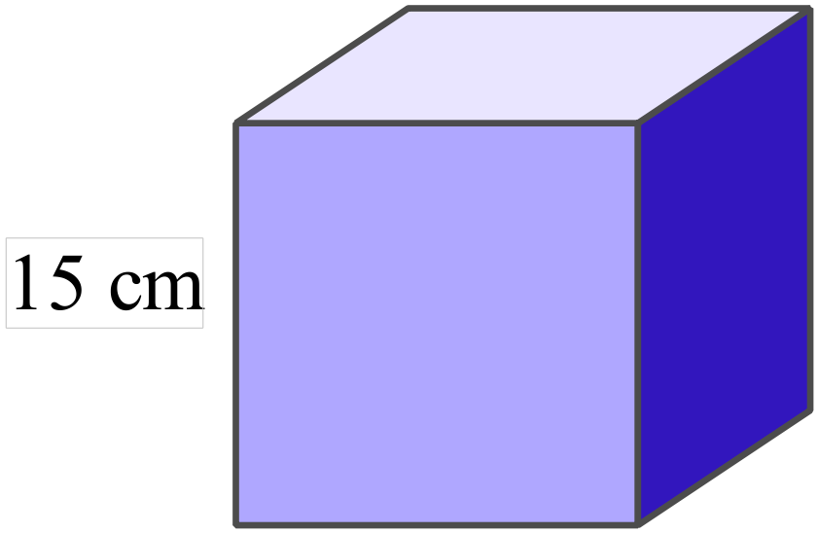What is the volume of the cube shown?

……………………………………………………………………..

……………………………………………………………………..

……………………………………………………………………..
What is the volume of the rectangular prism?

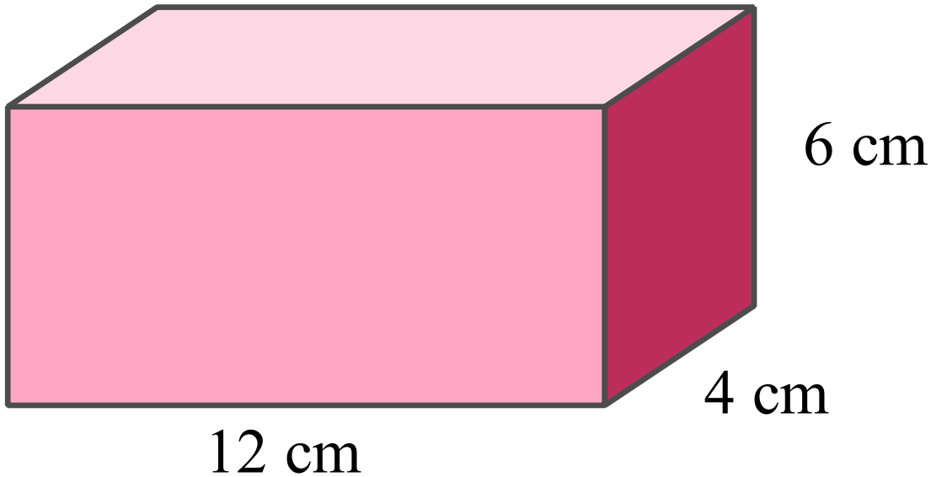
…………………………………………………………..

…………………………………………………………..

…………………………………………………………..

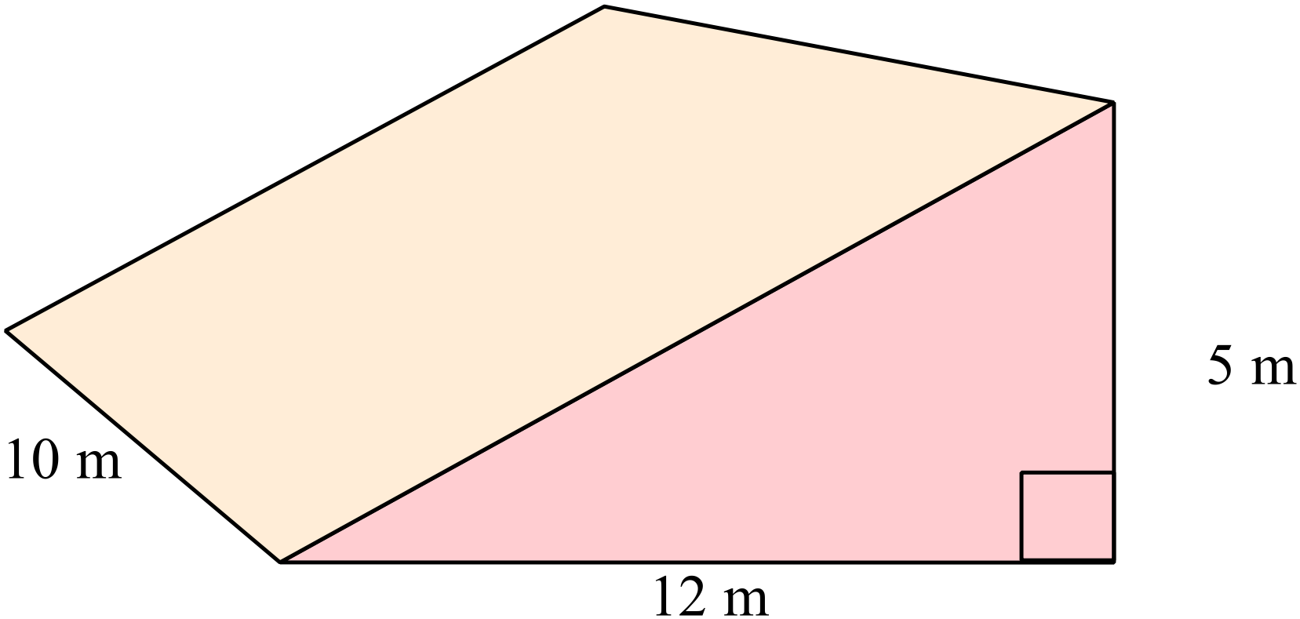Find the volume of the triangular prism shown.

.………………………………………………….

…………………………………………………..

…………………………………………………..

…………………………………………………..
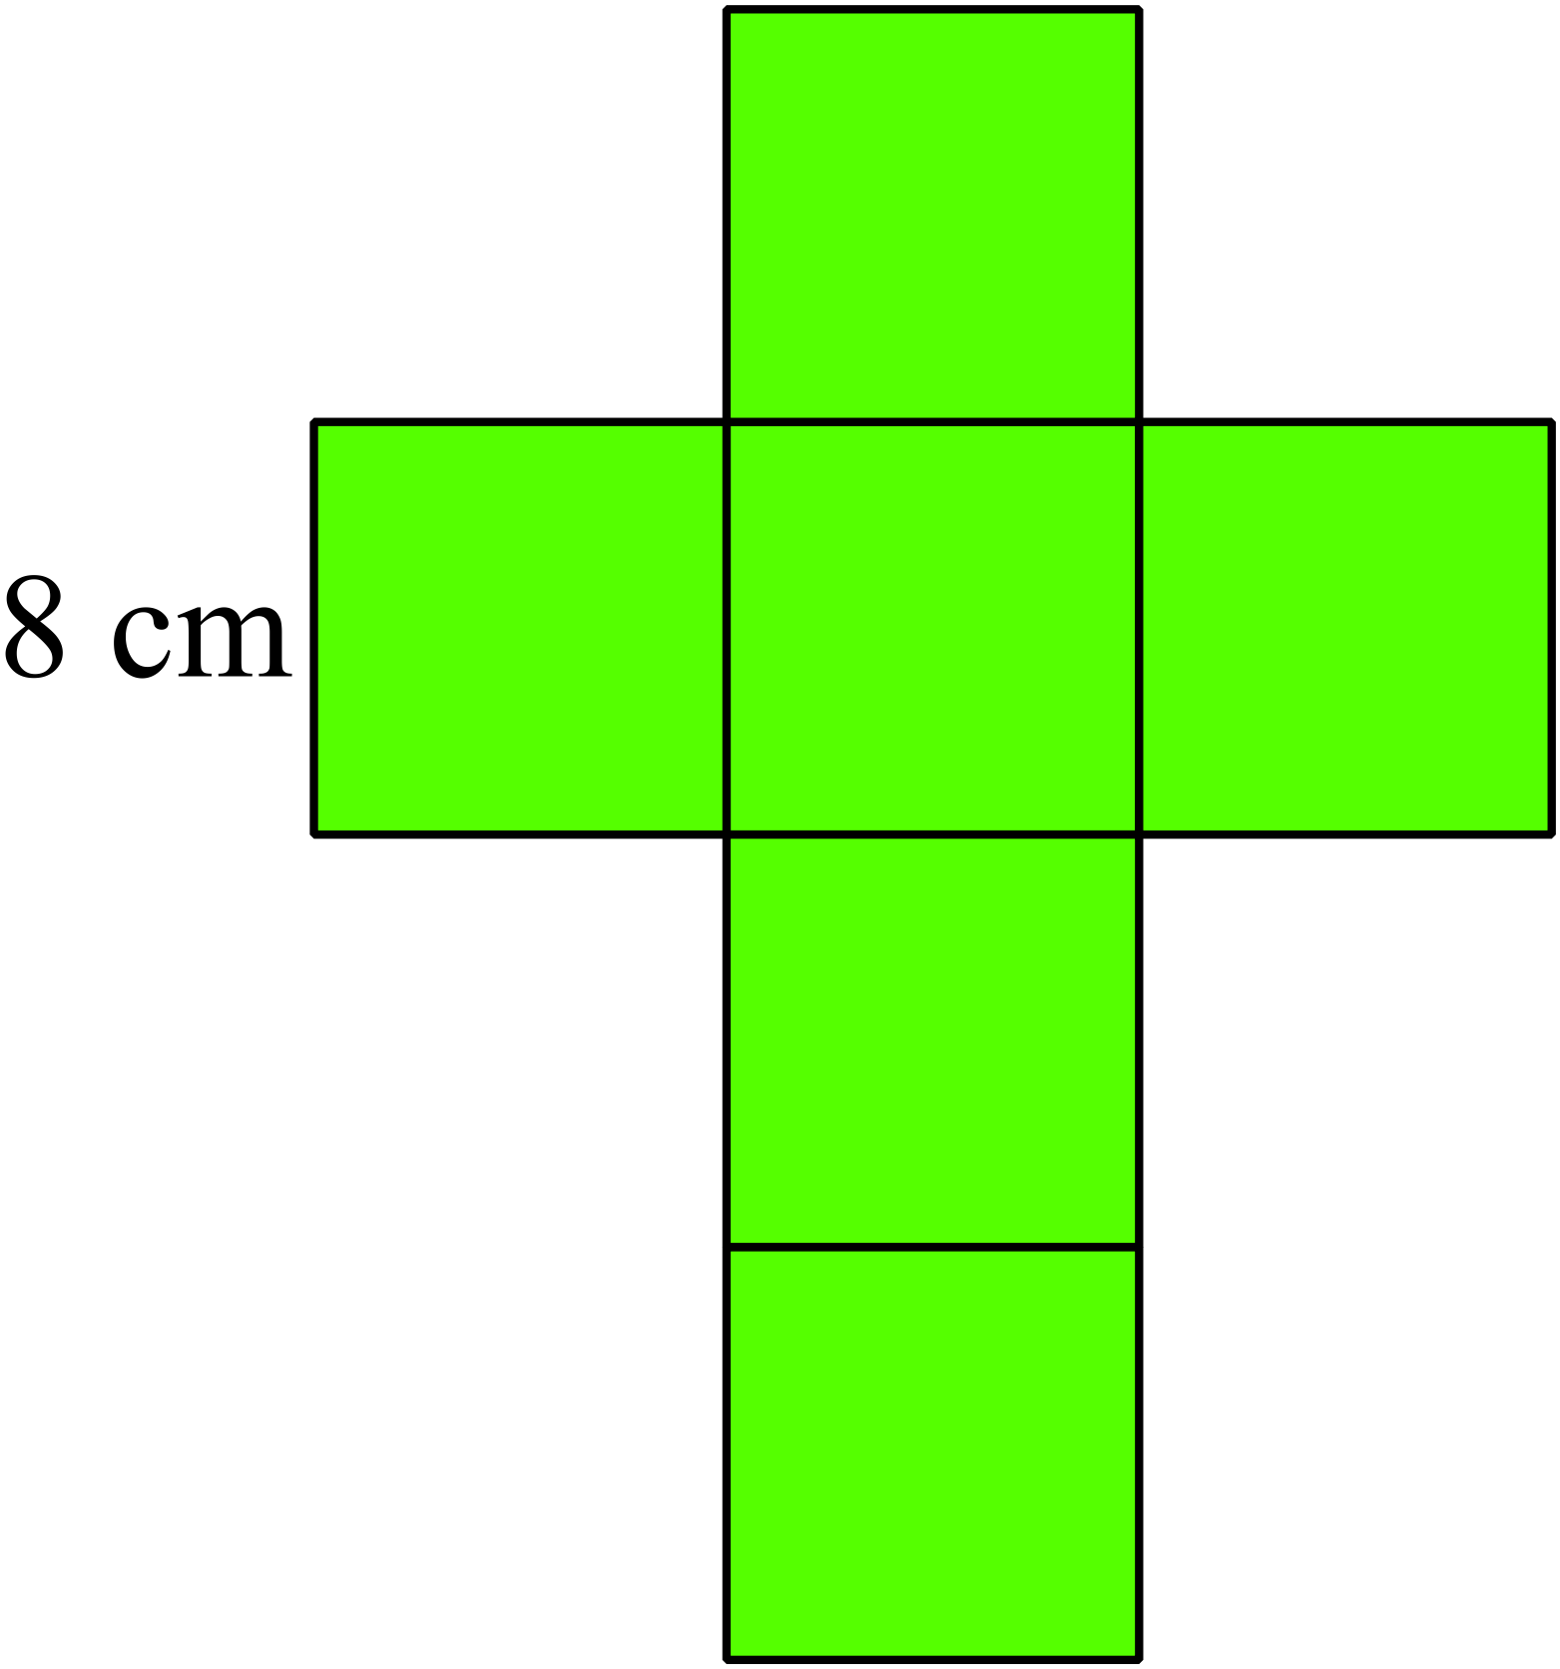What is the surface area of the cube formed from the net shown?

……………………………………………………

……………………………………………………

……………………………………………………

……………………………………………………
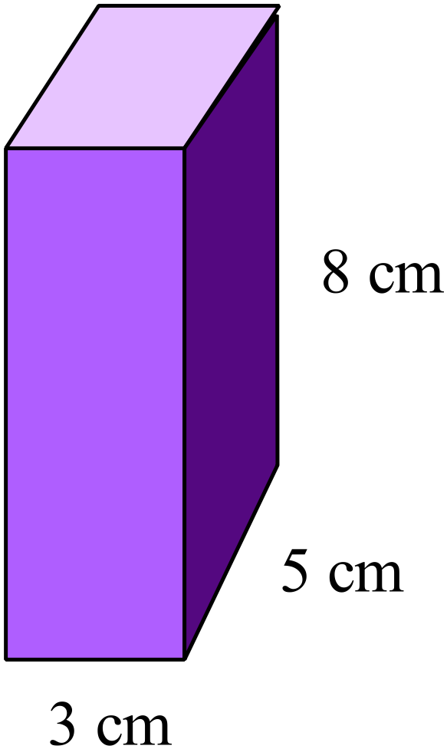What is the surface area of the rectangular prism shown?

……………………………………………………

……………………………………………………

……………………………………………………

……………………………………………………
An advertising sign for Hayman Island is in the shape of the island and is 5 cm thick.
The sign is made of wood and has an area of 850 cm².
What volume of wood is in the sign?

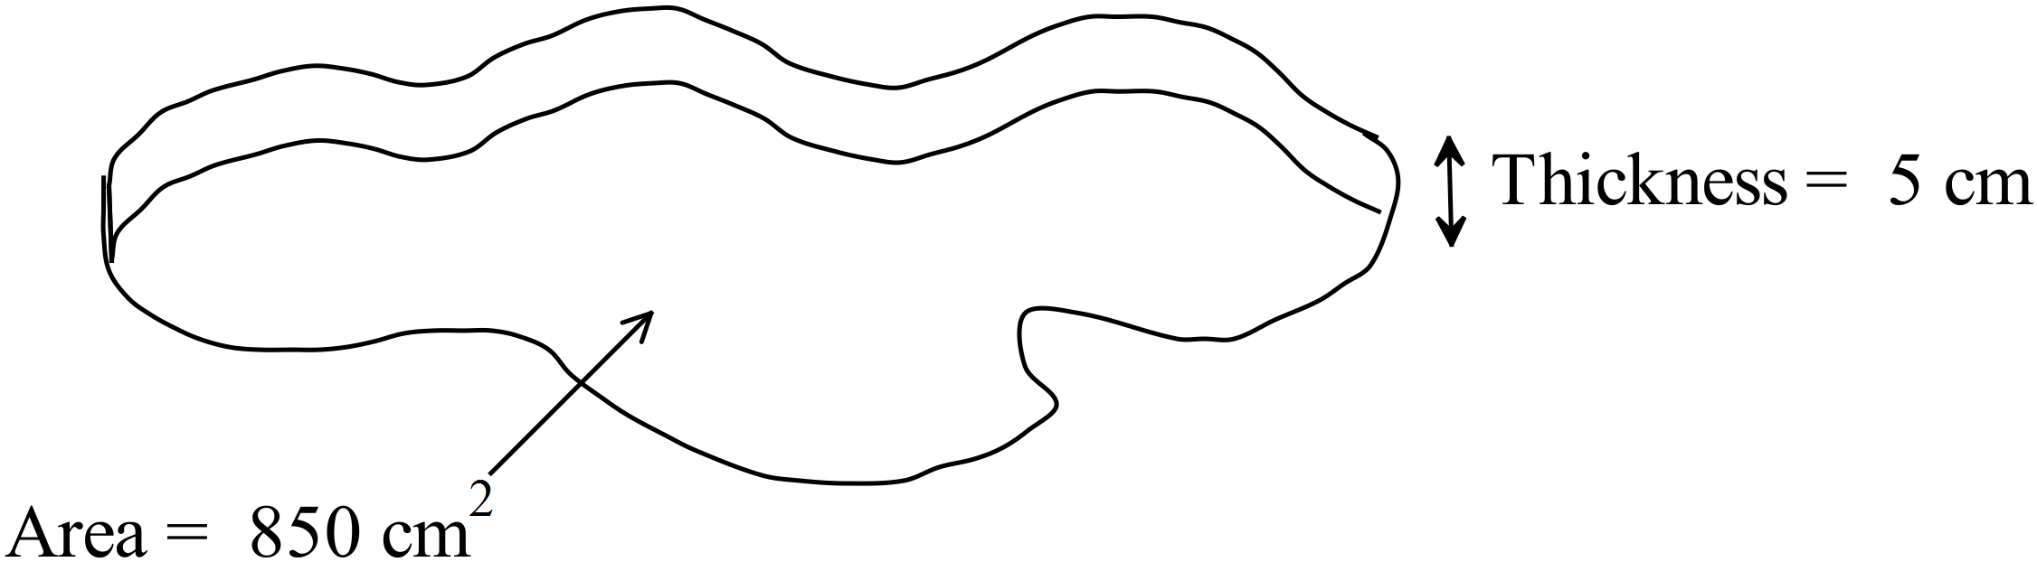
……………………………………………

……………………………………………

……………………………………………

……………………………………………

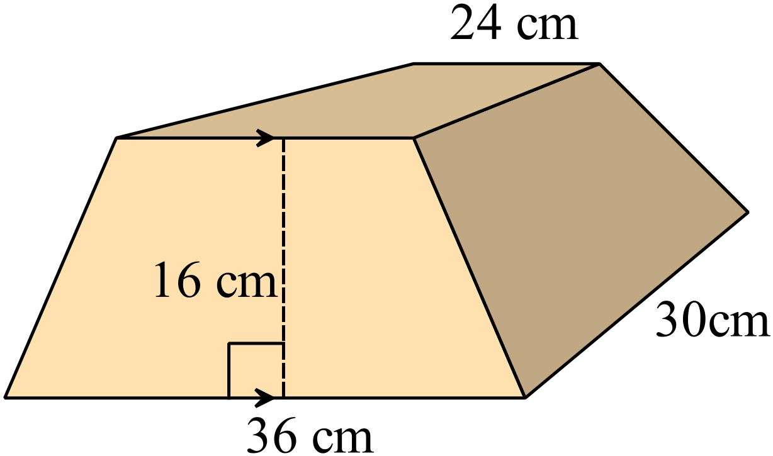What is the volume of the trapeziodal prism shown?

.............................................................................

.............................................................................

.............................................................................

.............................................................................
What is the volume of the triangular prism shown?
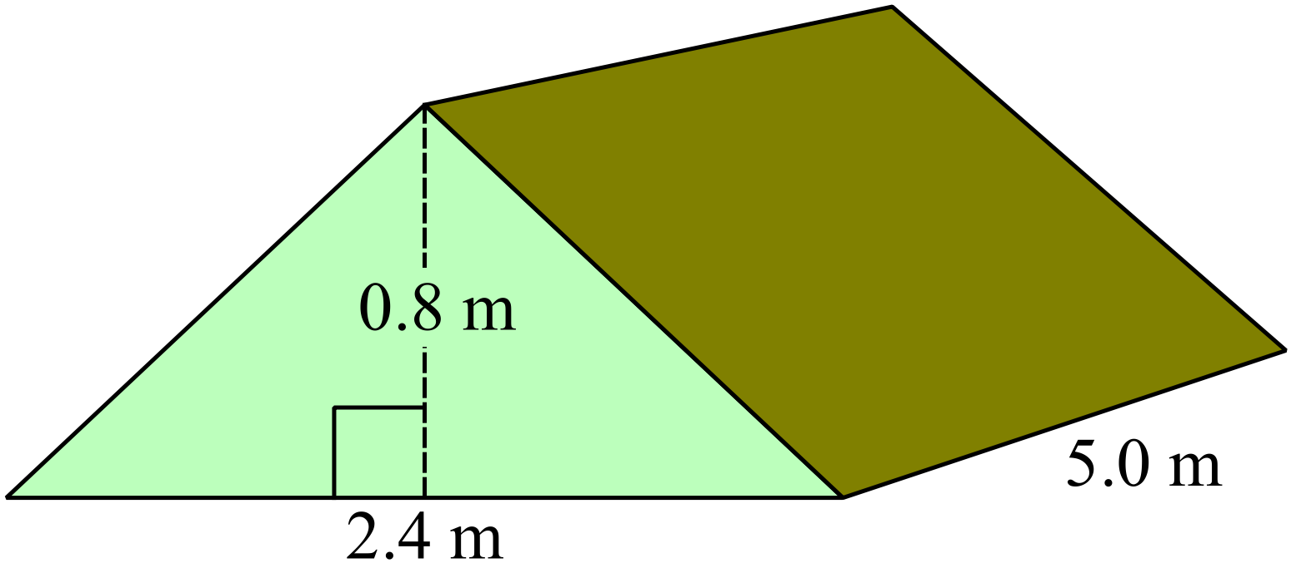
.............................................................................

.............................................................................

.............................................................................

.............................................................................
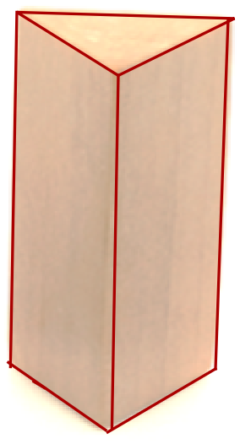The prism shown has a cross section which is an equilateral triangle with sides 4 cm and area approximately 6.9 cm². Its height is 12 cm.

What is its surface area??

……………………………………………………

……………………………………………………

……………………………………………………

……………………………………………………
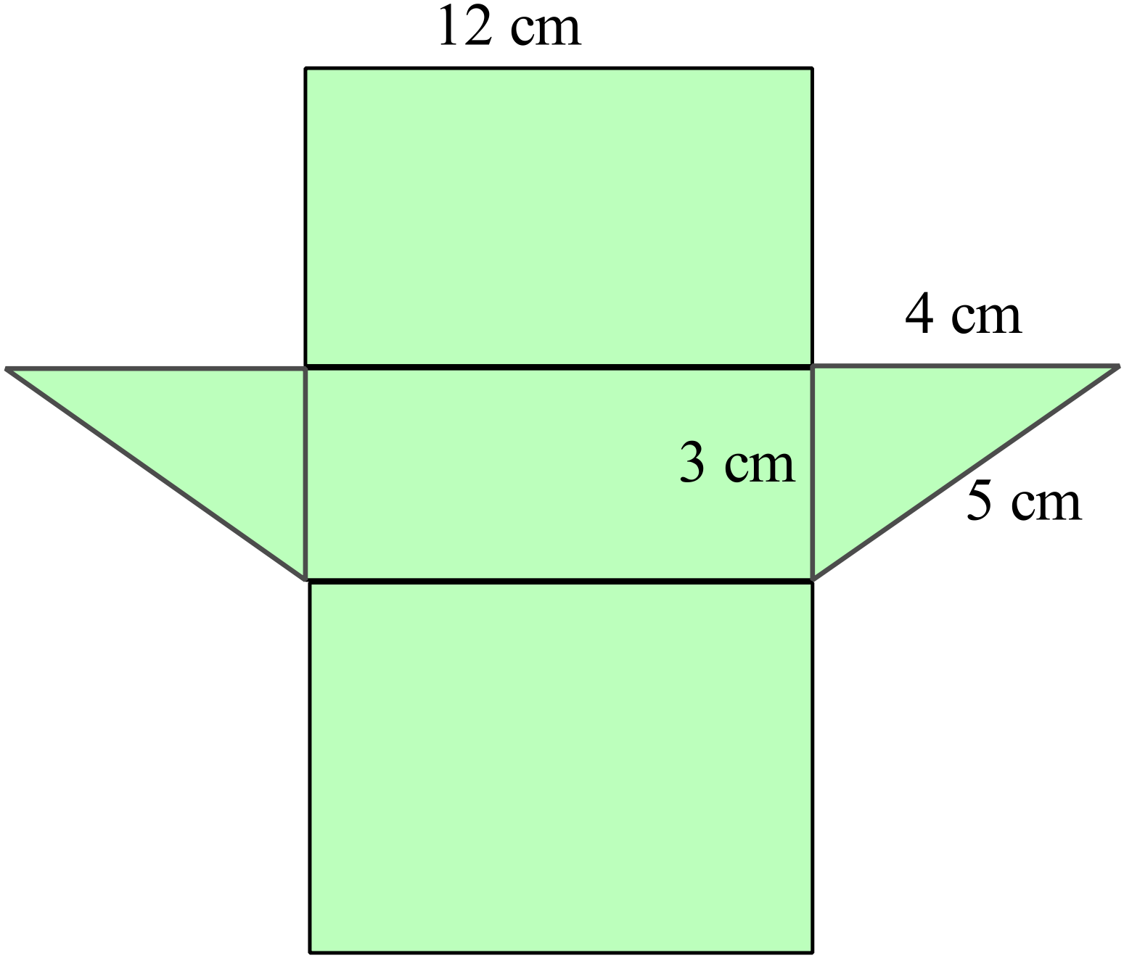Find the surface area of the prism whose net is shown.

……………………………………………………

……………………………………………………

……………………………………………………

……………………………………………………
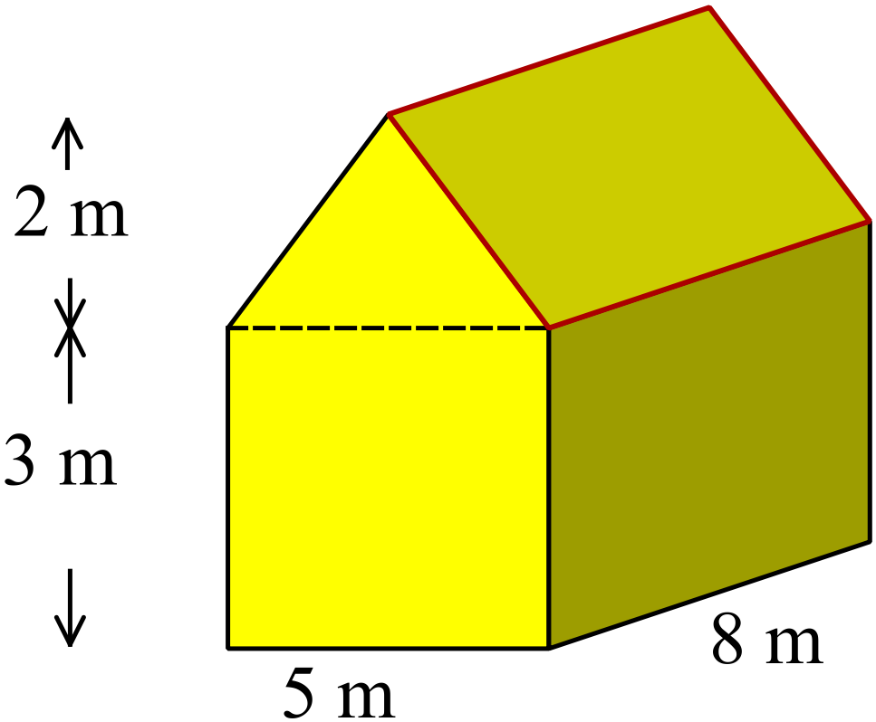What is the volume of the prism shown?

.............................................................................

.............................................................................

.............................................................................

.............................................................................

.............................................................................
Find the volume of this half cylinder.
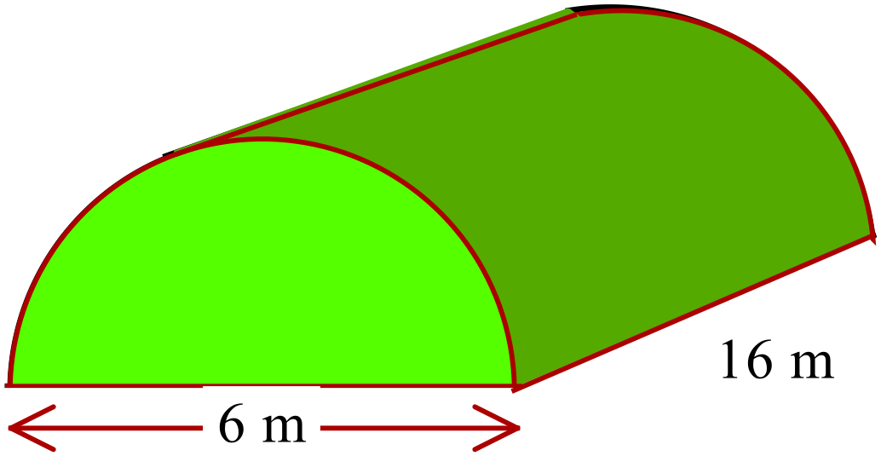Answer in terms of 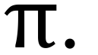

……………………………………………………

……………………………………………………

……………………………………………………

……………………………………………………
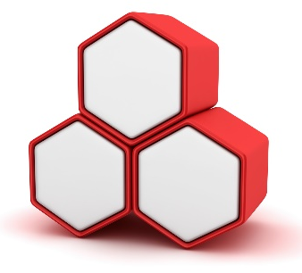
Each of these hexagonal boxes has a depth of 20 cm and the hexagonal top of each has an area which can be broken into two trapezia as shown.

Find the total volume of the three boxes.

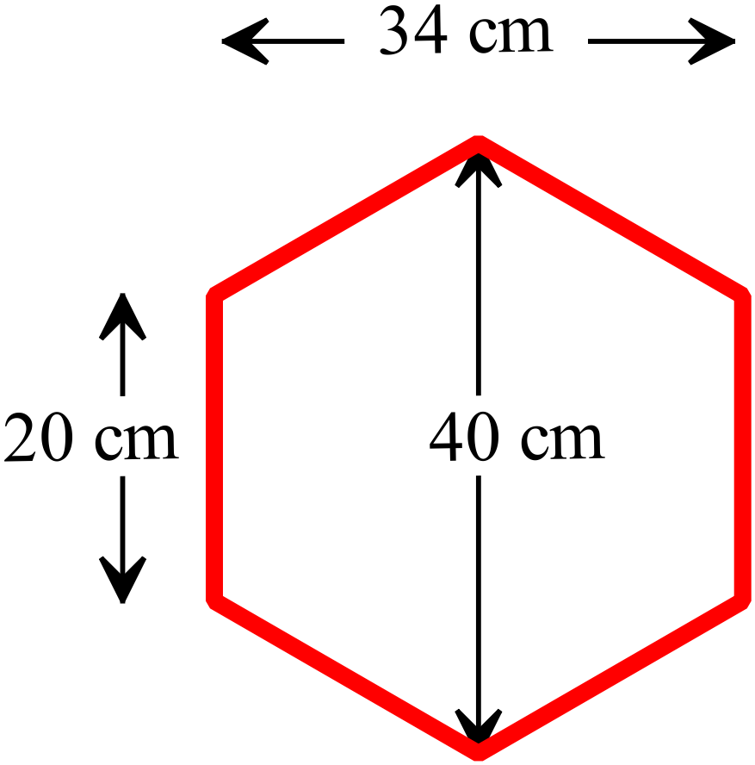……………………………………………………

……………………………………………………

……………………………………………………

……………………………………………………

The prism shown has a rhombus as its cross section.
Find the surface area of the prism.

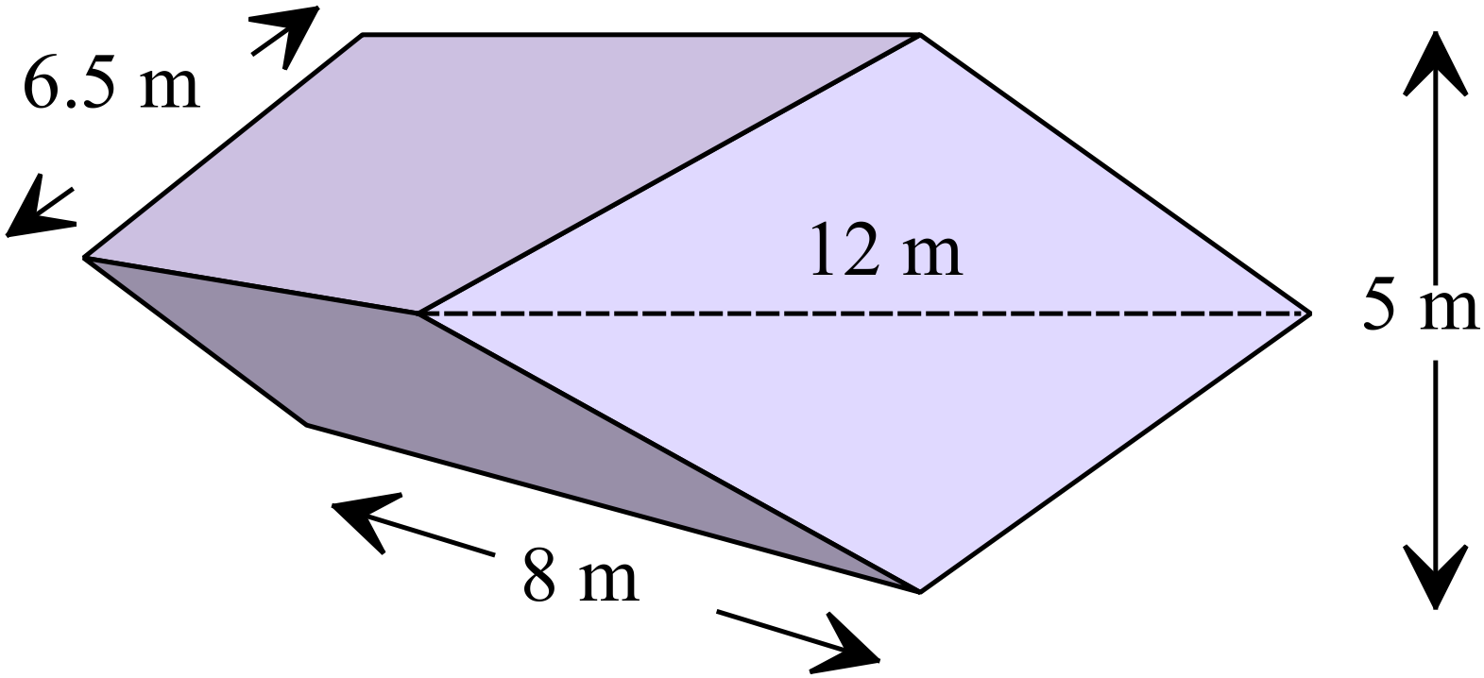.............................................................................

.............................................................................

.............................................................................

.............................................................................

A solid wooden cylinder has been cut in half to give this solid.
Find its surface area (in terms of 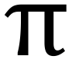).

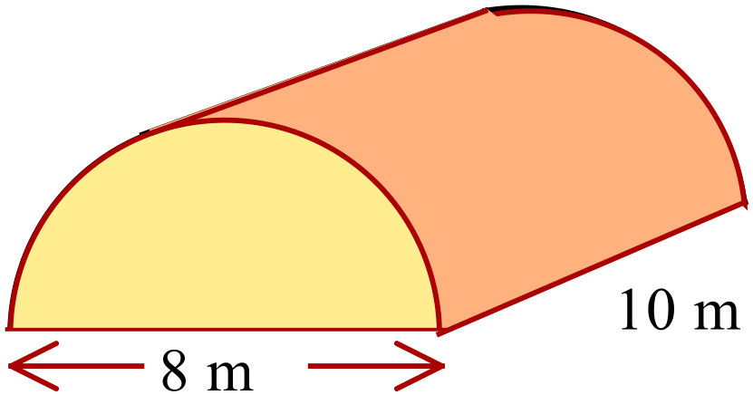.............................................................................

.............................................................................

.............................................................................

.............................................................................

.............................................................................

Year  9 |  | Volume and SA of Prisms and Cylinders | Calculator Allowed
 |  | Volume and SA of Prisms and Cylinders | Name_________________
Section 2 Multiple Choice Section
Mark all your answers on the accompanying multiple choice answer sheet, not on this test paper. You may do any working out on this test paper. Calculators are allowed for this section.

The solid shown is made using 1 cm cubes.
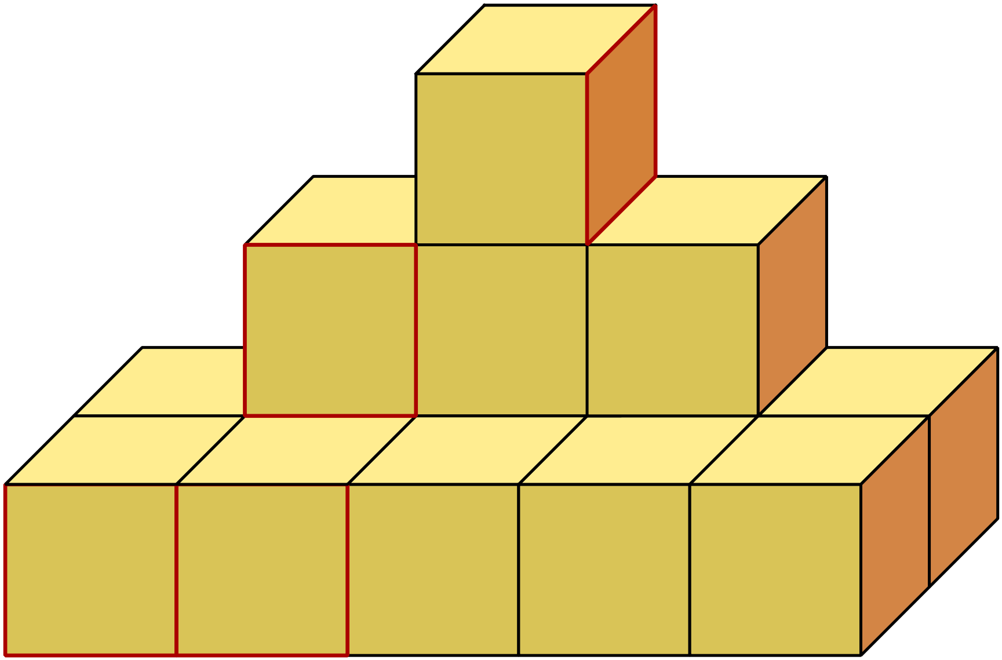
What is the total volume of the solid?

A. 11 cm³

B. 13 cm³

C. 14 cm³

D. 15 cm³

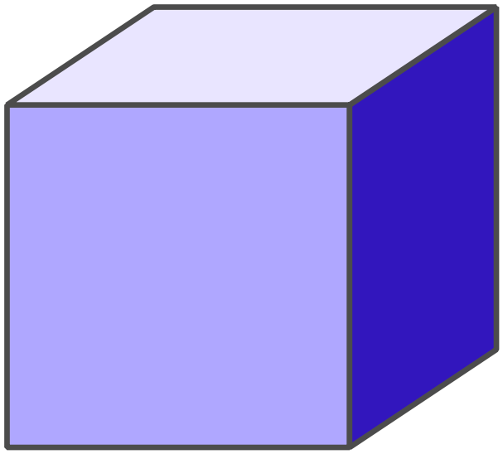The cube shown has a volume of 13.824 cm³.

What is its side length?

A. 1.4 cm

B. 2.4 cm

C. 2.8 cm

D. 3.4 cm

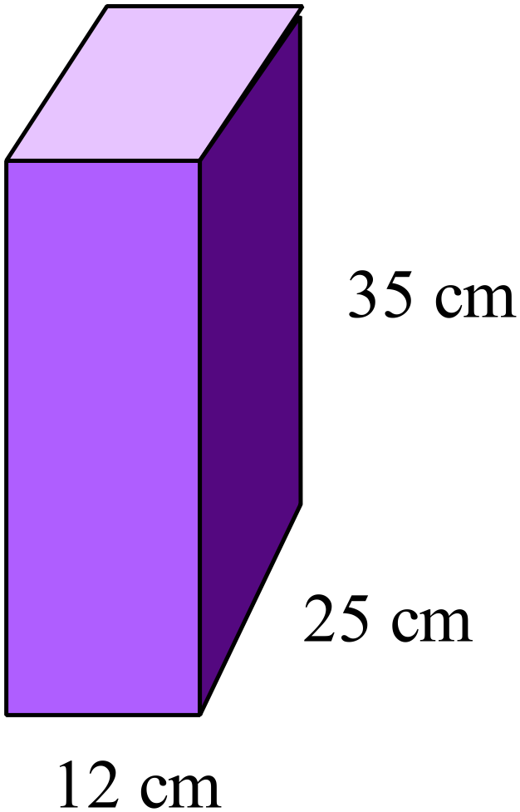What is the volume of the prism shown in cm³?

A. 814 cm³
B. 105 cm³
C. 1 050 cm³
D. 10 500 cm³

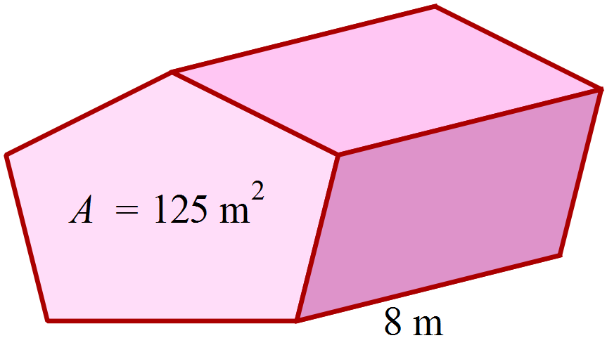The area of the pentagonal base of this prism is 125 m².

What is the volume of the prism?

A. 250 m³
B. 500 m³
C. 875 m³
D. 1 000 m³

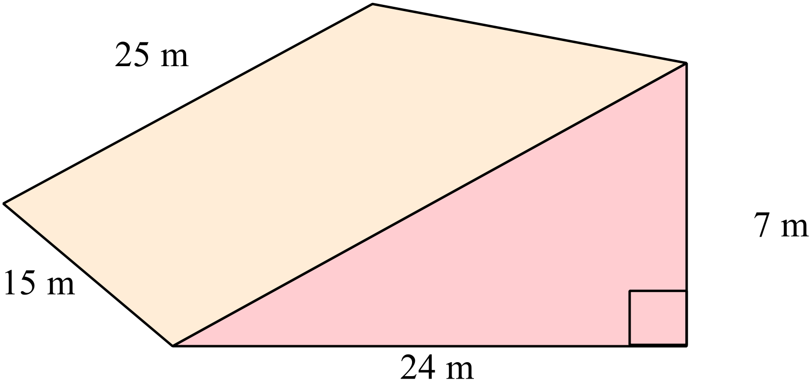Which calculation could be used to find the volume of the triangular prism shown?

A. 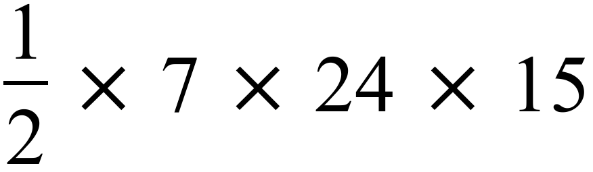

B. 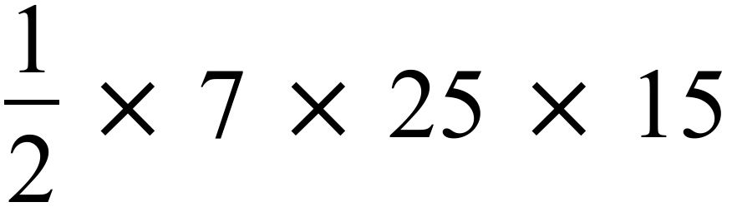

C. 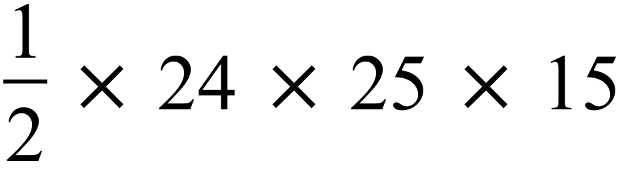

D. 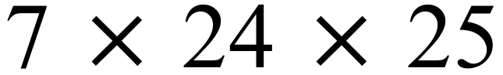

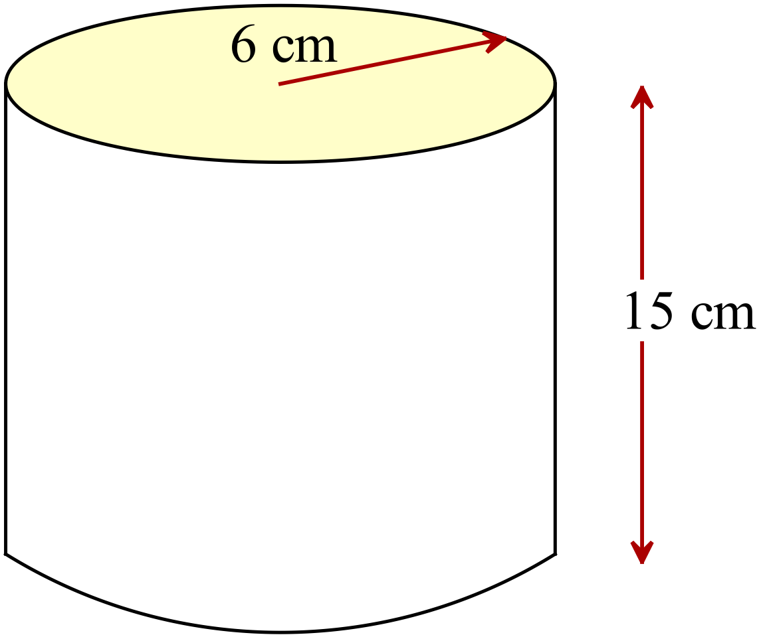What is the volume of the cylinder to the nearest cm³?

A. 1 696 m³
B. 3 393 m³
C. 5 089 m³
D. 6 786 m³

Find the volume of the triangular prism shown.

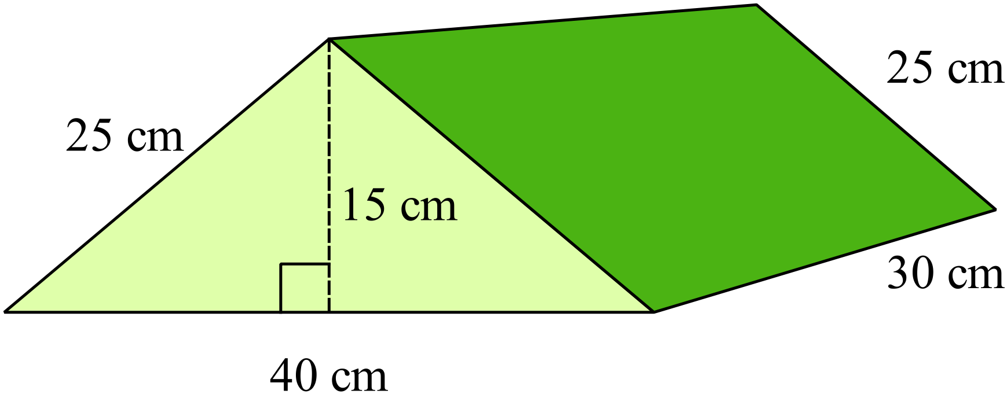
A. 4 500 m³
B. 9 000 m³
C. 15 000 m³
D. 18 000 m³

An air conditioning duct is in the shape of the trapezoidal prism, with cross section as shown below and a length of 14 metres. What is the volume of air held in the duct?
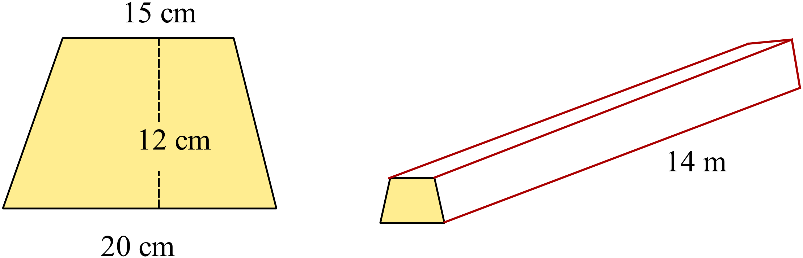

A. 210 cm³
B. 2 940 cm³
C. 5 880 cm³
D. 294 000 cm³

What is the surface area of the prism whose net is shown here?
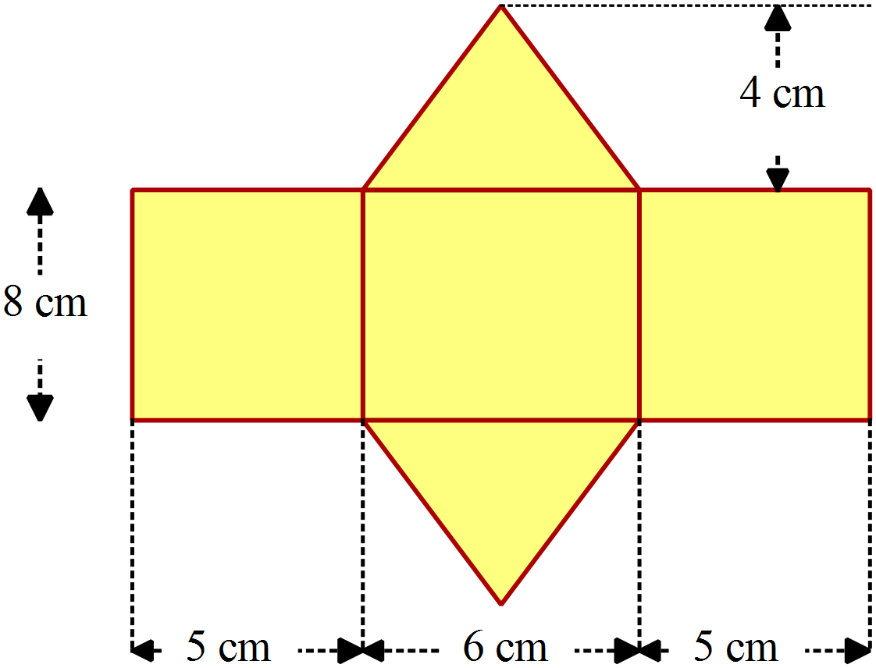

A. 112 cm³
B. 140 cm³
C. 152 cm²
D. 200 cm²

Find the surface area of the triangular prism shown.

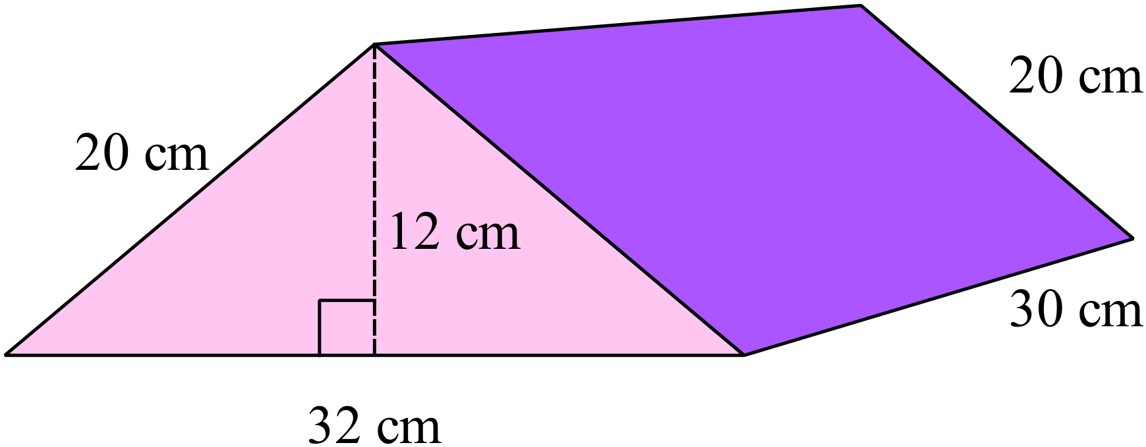
A. 984 m³
B. 1 584 m³
C. 1 944 m³
D. 2 544 m³

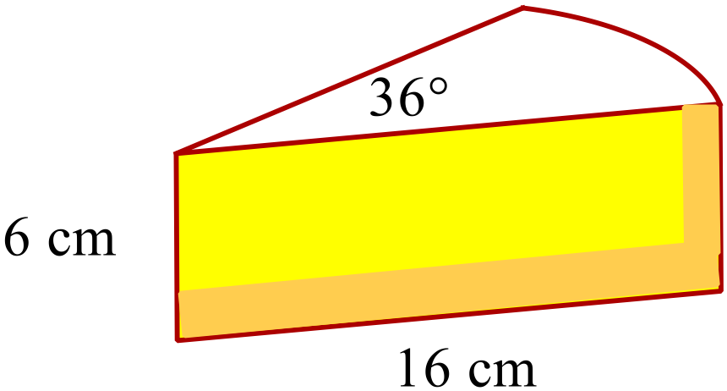A slice of pie, when viewed from above, is a sector of a circle with radius 16 cm and an angle of 36º.
The depth of the slice is 6 cm.

What is the approximate the volume of the slice?

A. 192 cm³ B. 480 cm³

C. 804 cm³ D. 1 930 cm³

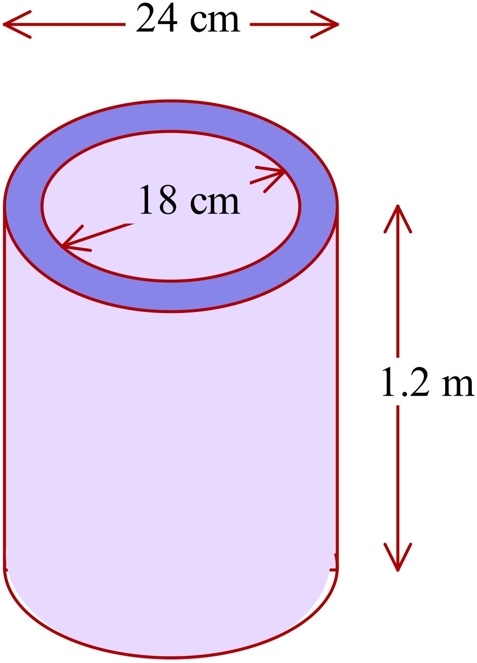A section of concrete pipe is cylindrical with an outside diameter of 24 cm and an inner diameter of 18 cm. The section is 1.2 m long.

What volume of concrete is used to make the pipe?

A. 238 cm³

B. 950 cm³

C. 23 750 cm³

D. 95 002 cm³

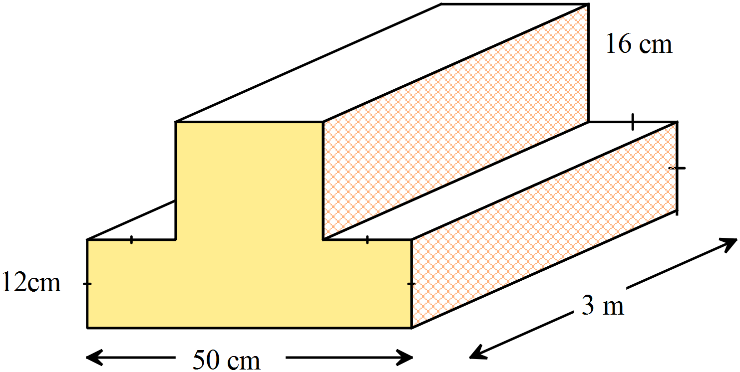Find the volume of the prism shown (in cubic metres).

A. 0.3048 m³

B. 3.048 m³

C. 30.48 m³

D. 3 048 m³

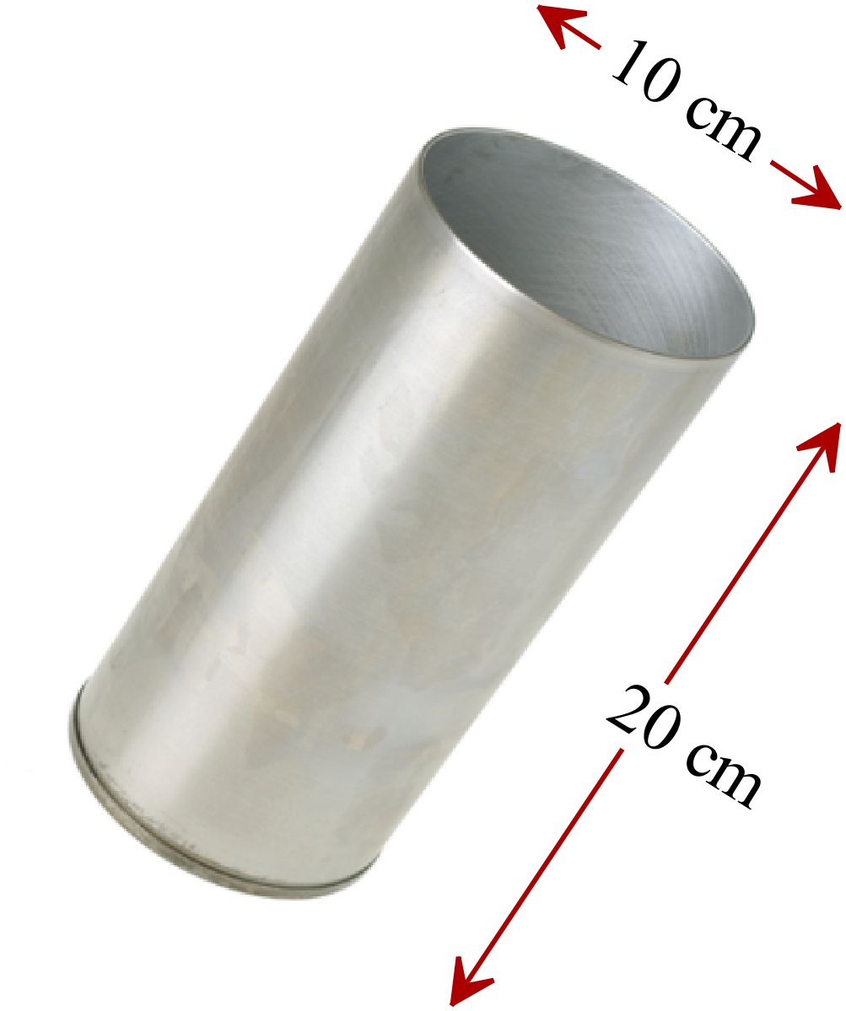A cylindrical metal beaker has a diameter of 10 cm and a depth of 20 cm and is open at one end.

Find the area of metal used to make the beaker.
A. 157 cm²

B. 628 cm²

C. 707 cm²

D. 785 cm²

A tractor shed is in the shape shown and is clad with sheet metal.
It is open at one end and has an earth floor.
What area of sheet metal is needed to clad the shed?
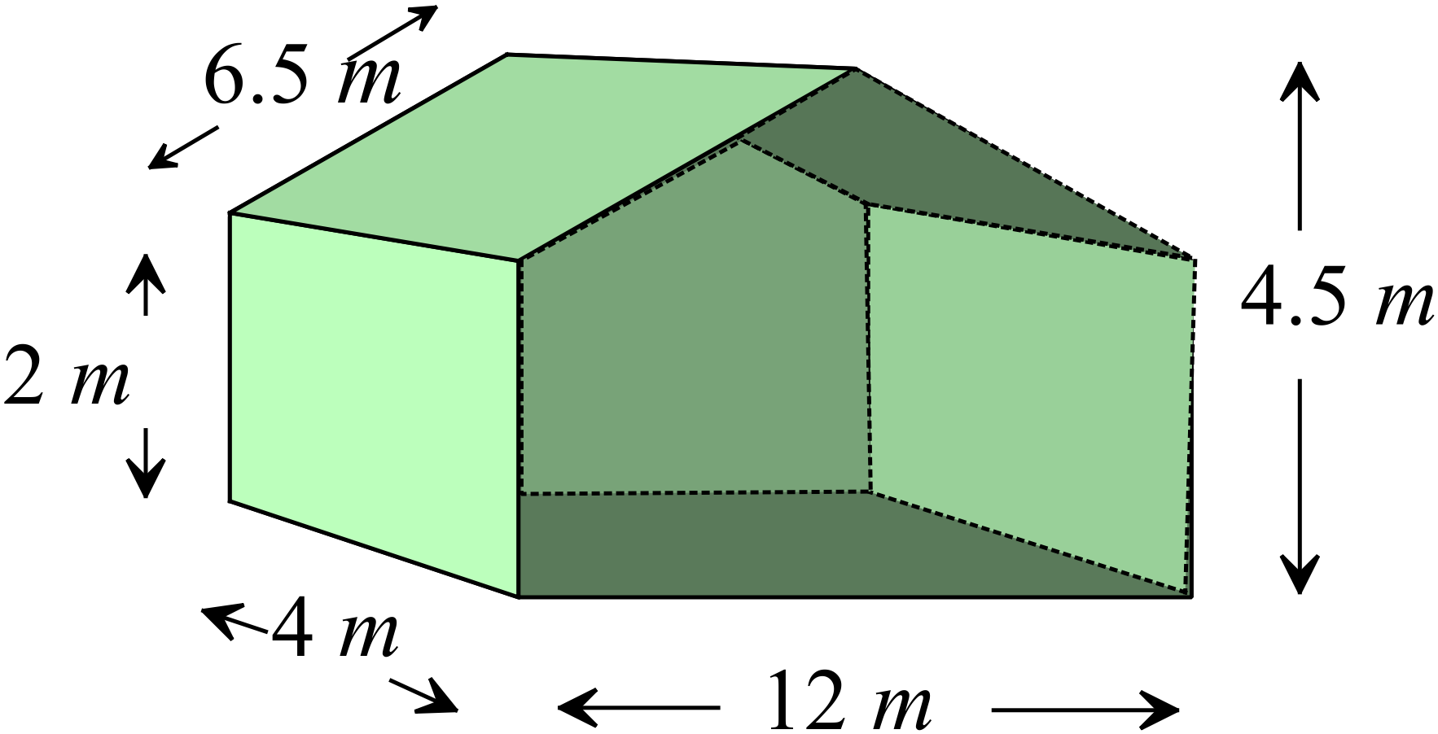

A. 55 m²
B. 68 m²
C. 91 m²
D. 107 m²

Volume and SA of Prisms and Cylinders

Multiple Choice Answer Sheet
Name _____________________________________________
Completely fill the response oval representing the most correct answer.

1. A B C D
2. A B C D
3. A B C D
4. A B C D
5. A B C D
6. A B C D
7. A B C D
8. A B C D
9. A B C D
10. A B C D
11. A B C D
12. A B C D
13. A B C D
14. A B C D
15. A B C D

Volume and SA of Prisms and Cylinders

ANSWERS
Section 1 ( 1 mark each)
Working and Answers
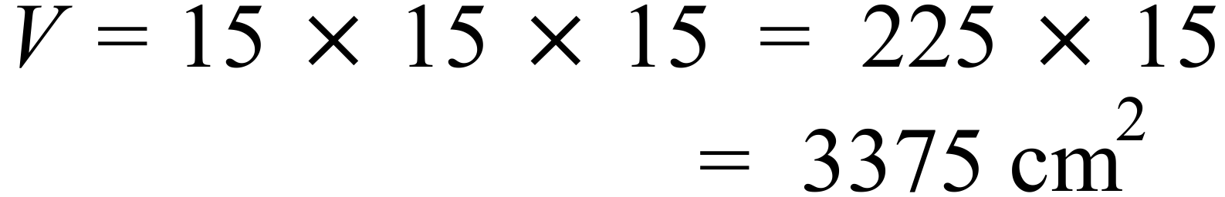

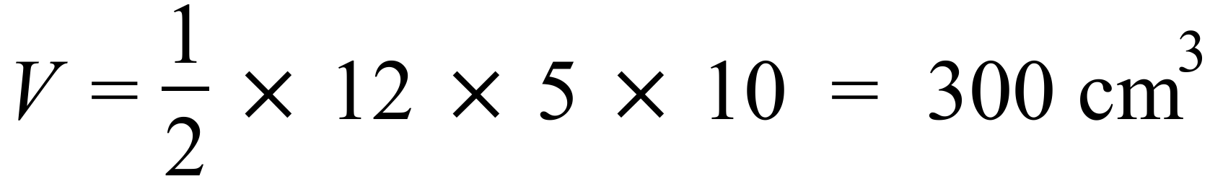
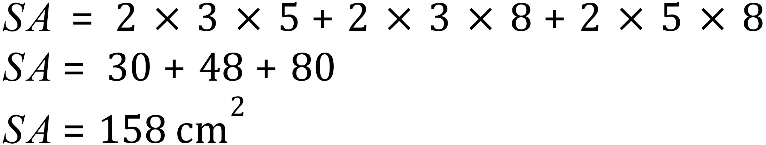
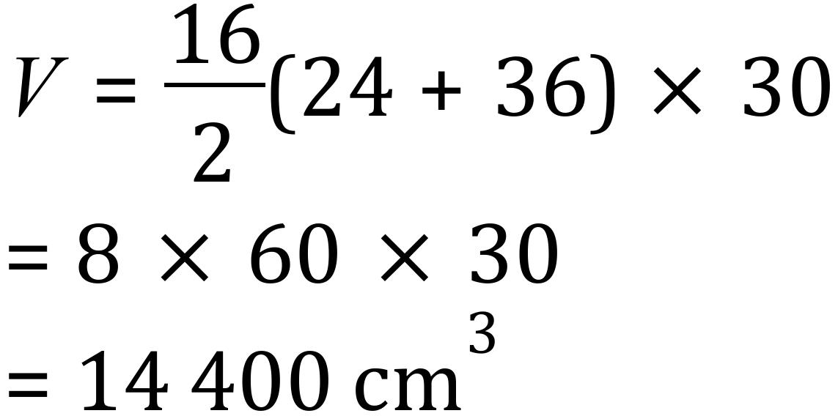
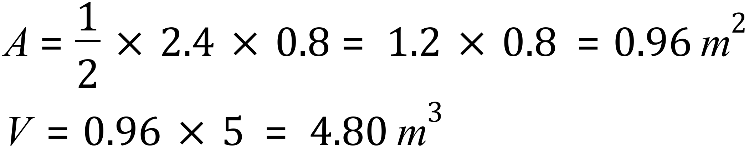
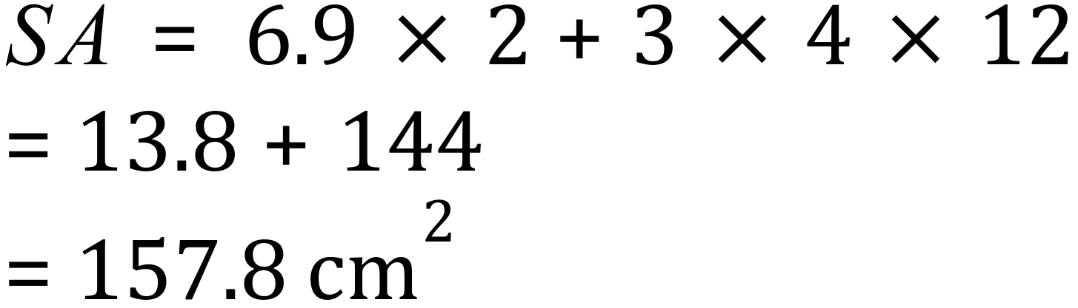
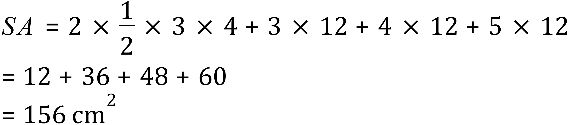
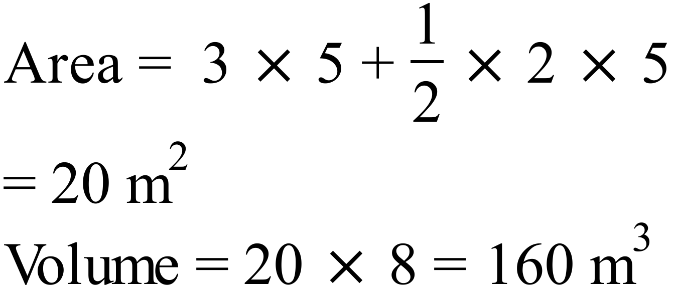
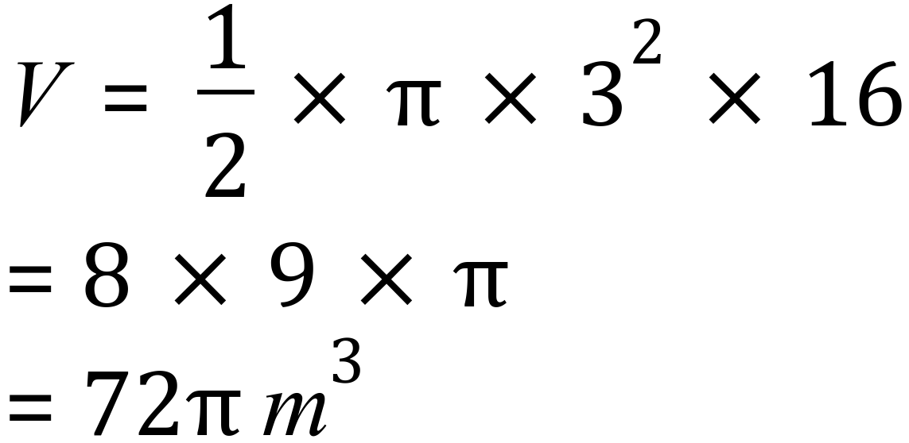
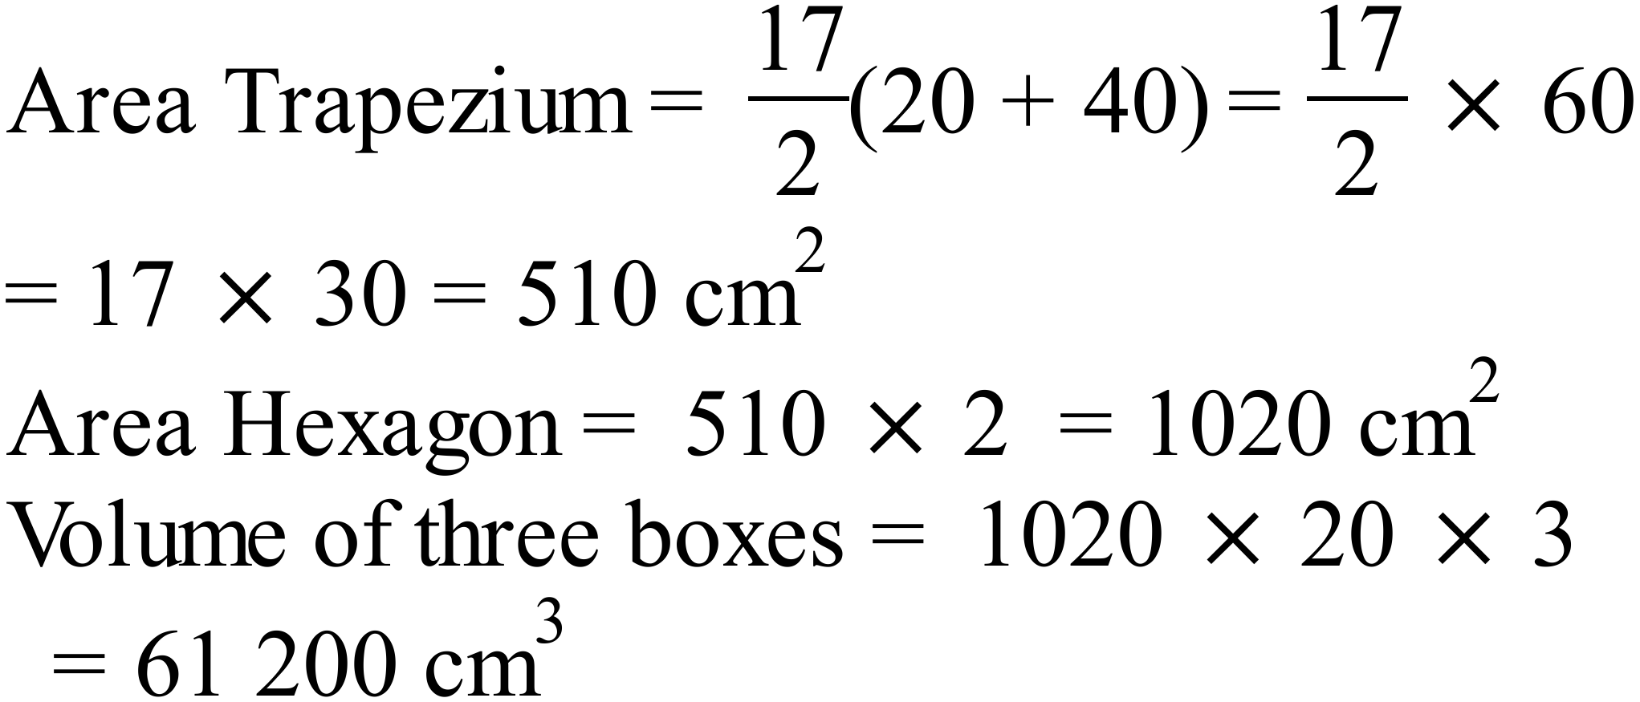
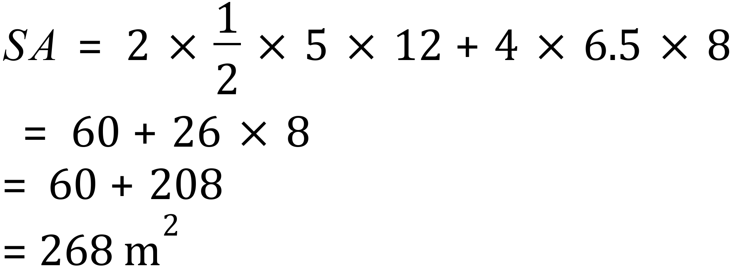
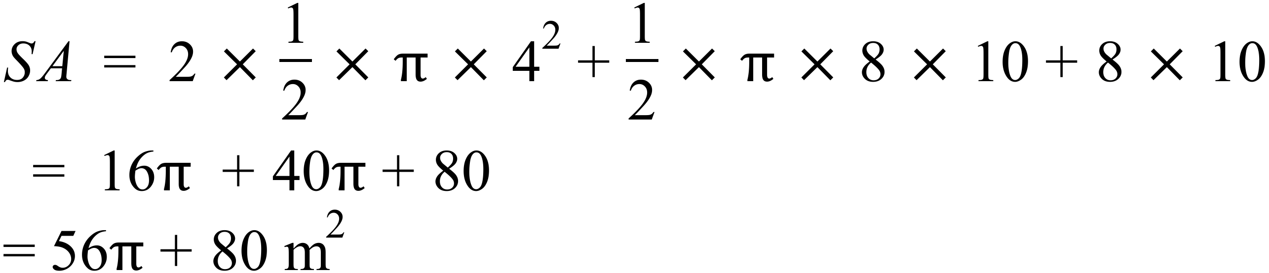

Section 2 (1 mark each)
 | Working | Answers
 | 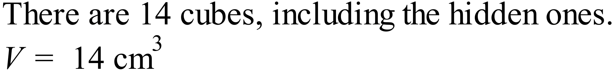 | C
 | 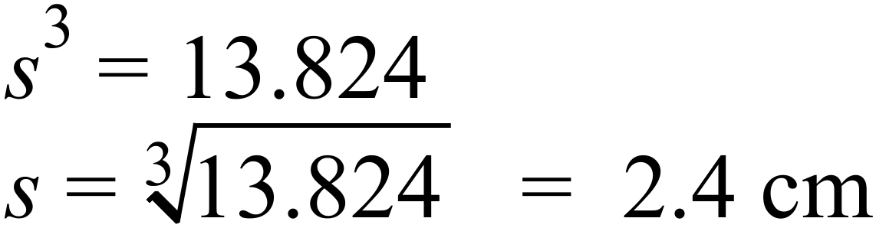 | B
 | 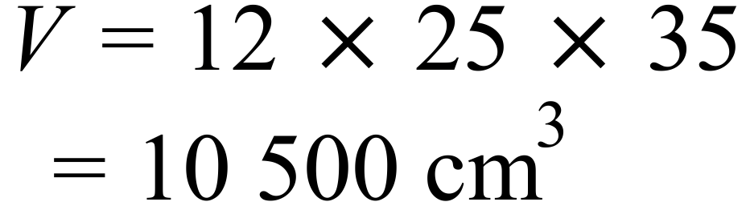 | D
 | 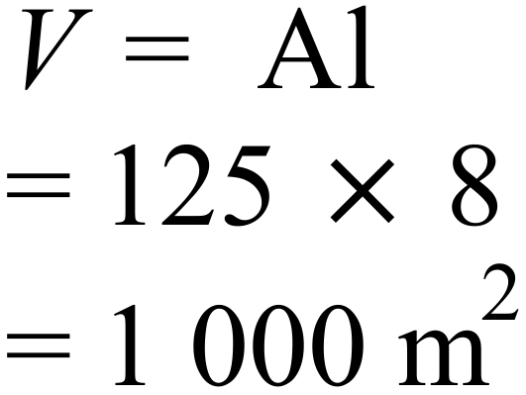 | D
 | 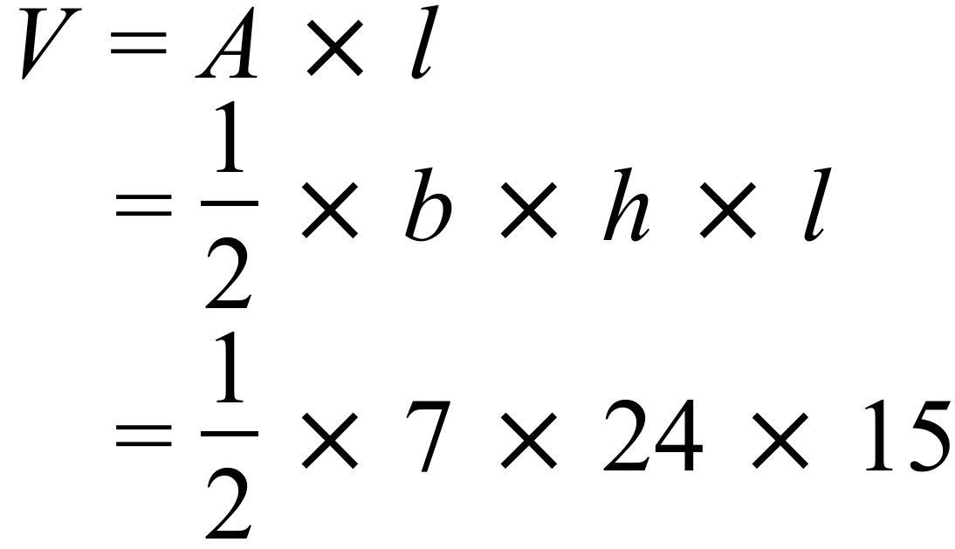 | A
 | 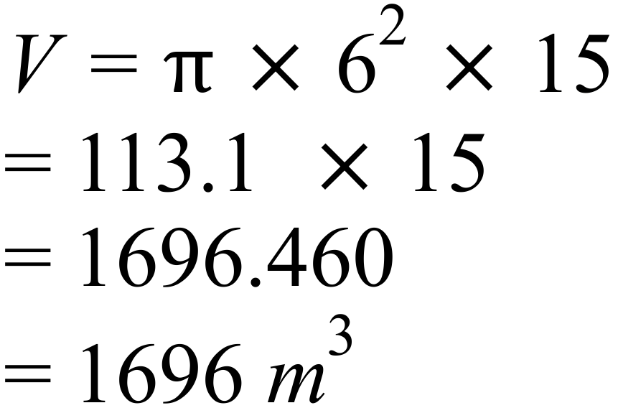 | A
 | 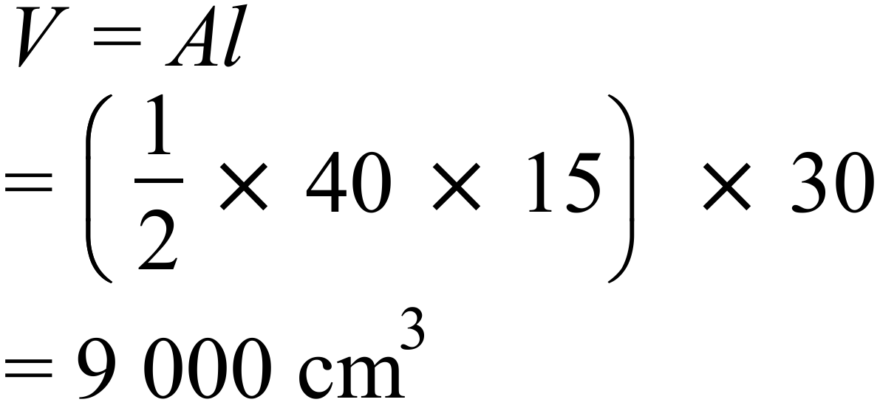 | B
 | 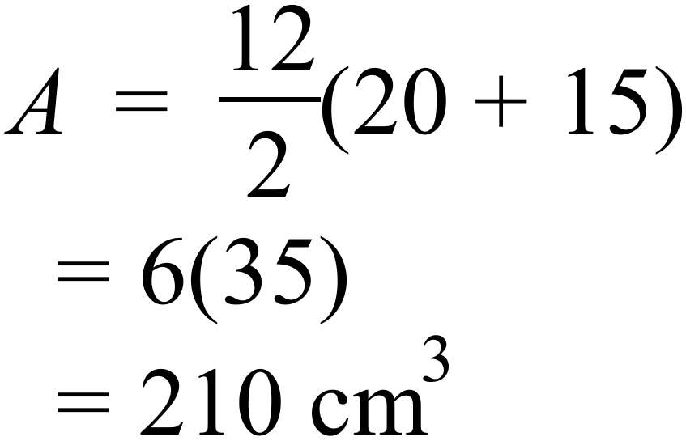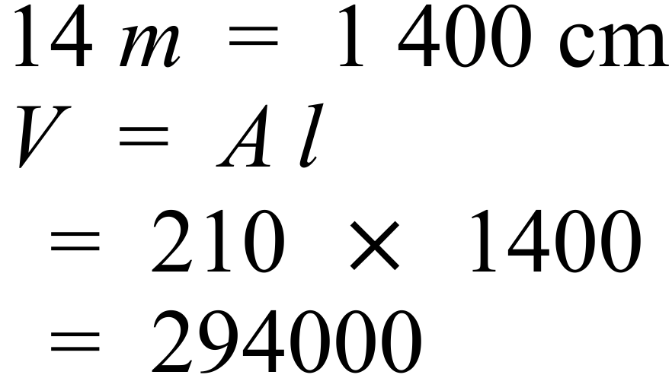 | D
 | 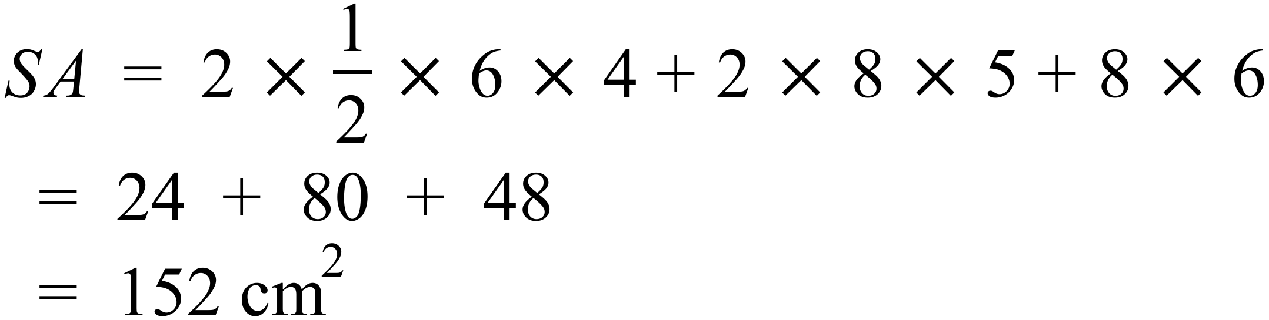 | C
 | 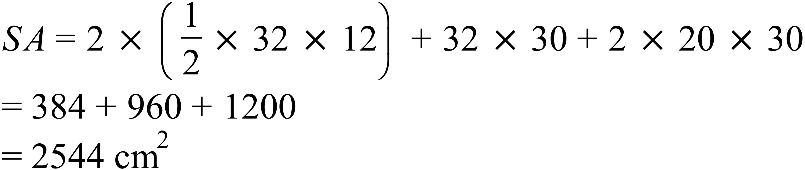 | D
 | 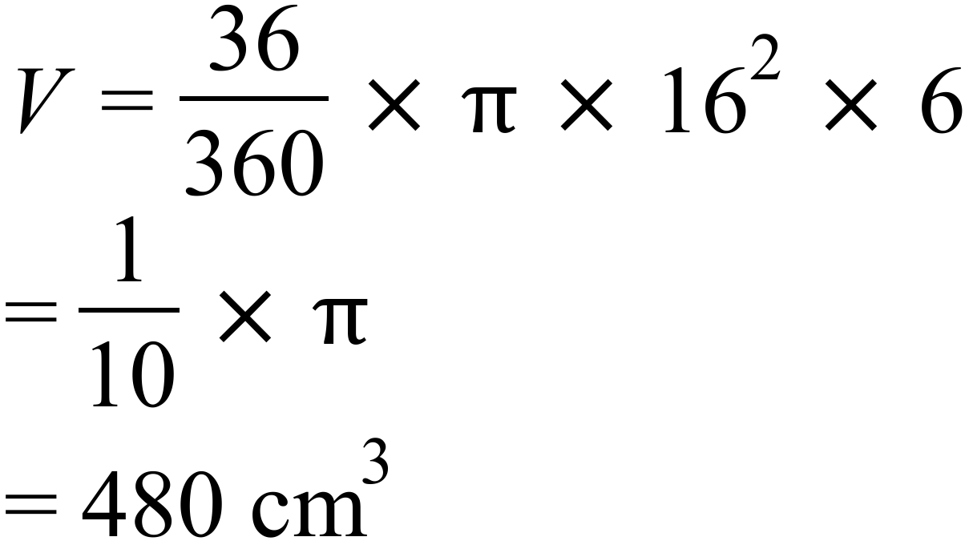 | B
 | 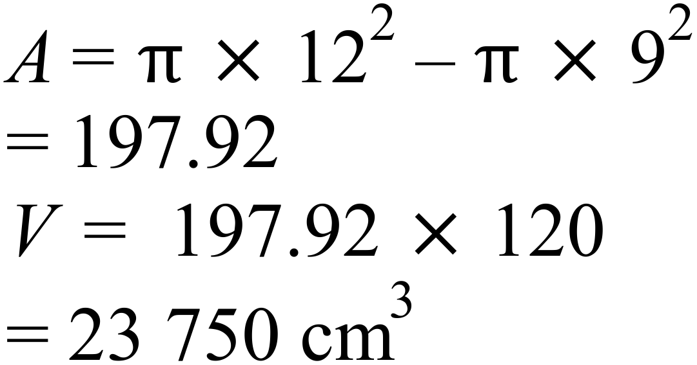 | C
 | 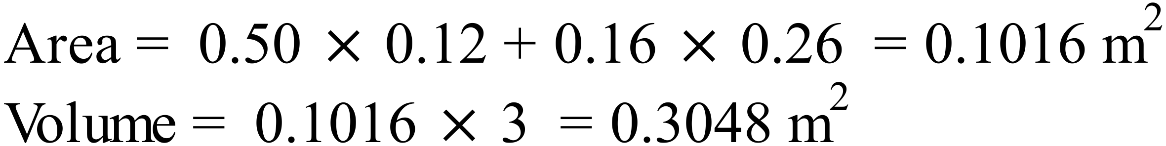 | A
 | 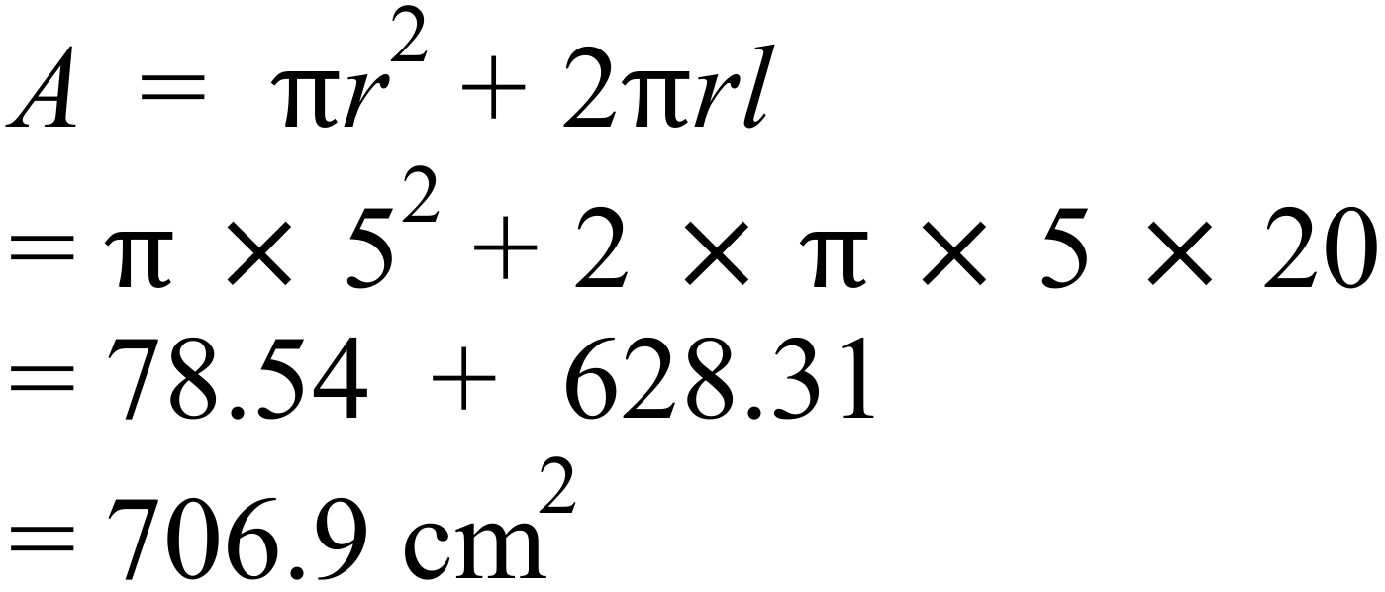 | C
 | 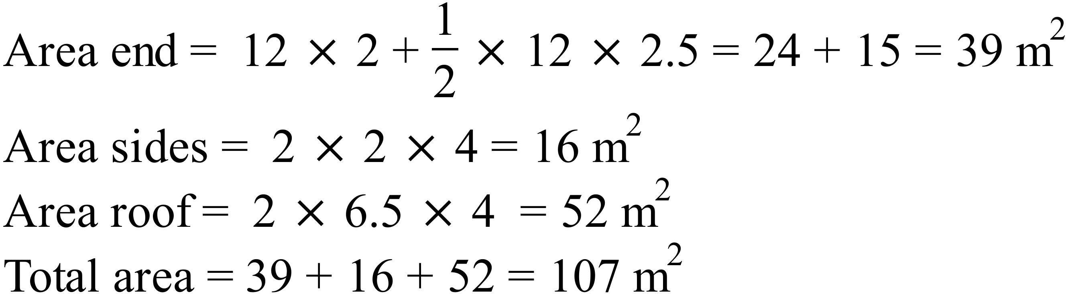 | D

Volume and SA of Prisms and Cylinders

Multiple Choice Answer Sheet
Name ___ Marking Sheet
Completely fill the response oval representing the most correct answer.

1. A B C D
2. A B C D
3. A B C D
4. A B C D
5. A B C D
6. A B C D
7. A B C D
8. A B C D
9. A B C D
10. A B C D
11. A B C D
12. A B C D
13. A B C D
14. A B C D
15. A B C D

